CHAPTER 2: Getting into genes
Worksheet 2.1

Genes and chromosomes
Student: Class:

Humans and cats
1. The following diagrams show the chromosome map of a human and a cat. The human chromosomes are shown as single stranded and the cat chromosomes are shown as double stranded.
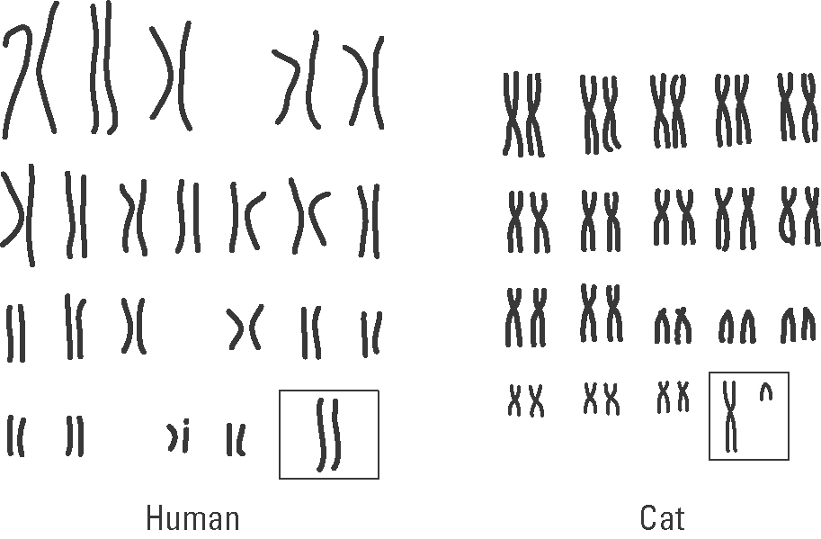
(a) What is happening when chromosomes appear as double strands?

(b) Compare the chromosomal number of humans and cats.

(c) Determine the sex of the human and the cat.

Klinefelter’s syndrome
2. Klinefelter’s syndrome is a genetic disease in human males. It leads to reduced fertility due to small testes. These males have poor beard growth, wider hips and show some breast development. The image below shows a chromosomal map for a male with this syndrome.
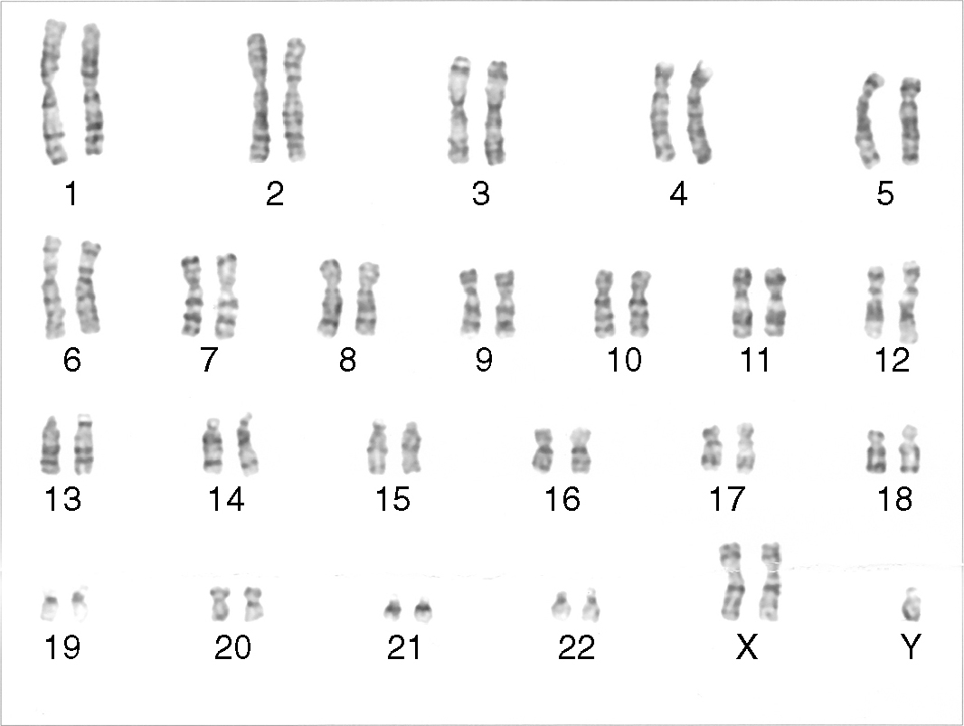
Photo: Public domain
CHAPTER 2: Getting into genes
Worksheet 2.1

Page 2

(a) Use the chromosomal map to identify the cause of this syndrome.

(b) Explain the differences in appearance of these affected males to normal males.

The fruit fly
3. (a) The following diagrams show the fruit fly’s chromosomes for male and female flies.
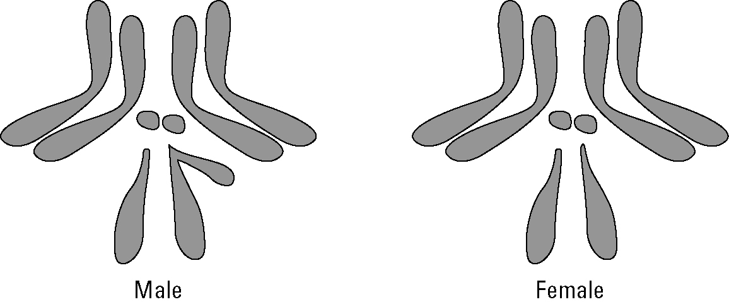
(i) How many chromosomal pairs does the fruit fly have in each cell?

(ii) Suggest why it took scientists less time to decode the genetic code of fruit flies
than humans.

(b) Genes on chromosomes may contain abnormalities. Consider chromosome number 2 for the fruit fly.
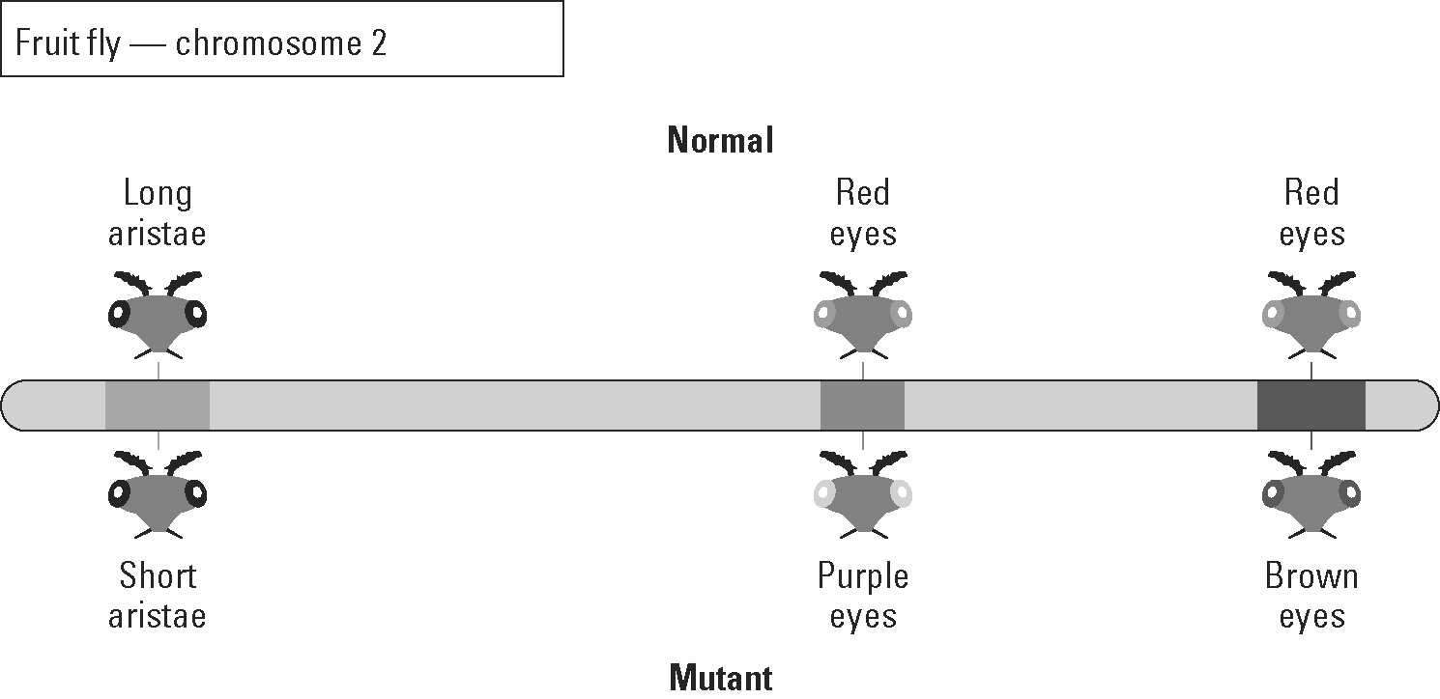
(i) What name is given to gene abnormalities?

(ii) Eye colour in fruit flies is determined by more than one gene. True or false?

